**CIS 229 – Python Programming – Programming Assignment**

**Guess My Number Again**

Overview

In this assignment, the student will upgrade the “Guess My Number” game to incorporate pseudo-random number generation and a simple menu interface.

When completing this assignment, the student should demonstrate mastery of the following concepts:

* Menu Creation
* Intuitive Interface Design
* Pseudo-random Number Generation
* Looping Control Structures
* Decision-making Control Structures

Assignment

In this assignment, you will be re-writing the number guessing game from weekly assignment #03. However, this time you have knowledge of looping, menu design, and pseudo-random number generation.

You will upgrade your game to begin by letting the user select a difficulty level and randomly generating the number to be guessed. Easy difficulty should create a number between 1-25 and give the player 5 guesses to reach victory. Medium difficulty should create a number between 1-100 and give the user 8 guesses to get the secret number. Hard difficulty should create a number between 1-1000 and give the user 12 guesses to get the number.

After a difficulty selection has been made, a random number in the appropriate range is created and the game begins. As the game progresses, guesses are obtained and the relation of the secret number to the guess (higher or lower) should be indicated to the player. Along with the prompt for each guess, display the number of remaining guesses the player currently possesses. If the player successfully guesses the number, end the game and display a victory message. If the user exhausts all of his/her guesses, display a defeat message and end the game.

In your program, use at least one looping structure, one instance of pseudo-random number generation, once instance of a function with a return value, and one instance of a function with multiple return values. Please refer to the provided examples as a reference point for how your program should behave.

Example Screen Shot #1

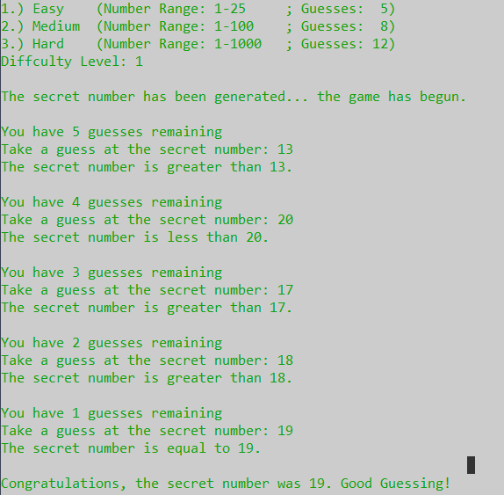

Example Screen Shot #2

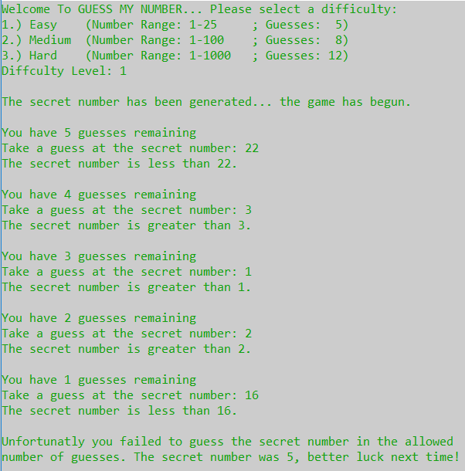

Assessment

This assignment will be assessed based on the provided grading rubric.